## Merchant

Scoping start date: N/A

Implementation Completed Date (Go live date): N/A

MSA Signature Date: Mar 31, 2024

GTM POC: Royce

ERP: NS

Tax Integration: No Tax

### 

### Key people at Merchant

### Accountant: [Mike Lawrence](mailto:mike.lawrence@redantler.com)

### CFO: [Rich Pacheco](mailto:rich.pacheco@redantler.com)

### 

| **AE/ Implementation Notes Sections**   * Open Invoice Set up   + [Red Anlter (Prod) Invoicing beyond 10.1.24](https://docs.google.com/spreadsheets/d/1q3Is6MWtv4YSYCiKhtaln2E-aIQE4IuCle1mm1Y853Q/edit?gid=0#gid=0) * Project ID Creation Steps   + [Red Antler - Description of Process.docx](https://docs.google.com/document/d/12lLuWc4reAQujnH98s-fRLztLe4-MCf_/edit)   Sales Notes   * Larger / Enterprise account for Tabs (ACV ~$40k) * [Red Antler x Tabs | 2024 Planning convo](https://docs.google.com/presentation/d/1ISWuZU_sYD0hub1f_xIx183UWOWO7SqNerHZya9j-QY/edit#slide=id.g2a644c08149_0_22) * [Red Antler x Tabs | 2024 Partnership Follow up](https://docs.google.com/presentation/d/1we1EdoWMyJrpFU-_pXjo054_JjzRnW5TrKs-JQl742c/edit#slide=id.g2ade9637bdc_1_0) * [Red Antler - Contracts onboarding](https://docs.google.com/presentation/d/1rLnjHlr7ctj43DdQePyK4MSZd7co19MM-Ri6wGX6ISY/edit#slide=id.g2b590538859_0_83) * [Red Antler - Description of Process.docx](https://docs.google.com/document/d/12lLuWc4reAQujnH98s-fRLztLe4-MCf_/edit) |
| --- |

### 

### Company summary

Red Antler LLC provides marketing services. The Company offers research, branding, naming, digital designing, engineering, and advertising services.

### 

### 

### Billing model

—---

For **RED ANTLER**

### Contract Processing Steps

For renewal contracts, process all BTs under the renewal contract.

**\*\*\*Contracts that already have a Sent /Paid invoice cannot have their Billing Terms changed.** New Edits / Additions / Requests from the merchant will have to go on an entirely new contract and will be on a separate invoice

* When you see a sent invoice on the contact in garage, ask the US team to duplicate the contract to put the new BTs under
* ***Revenue Schedule***
  + Find effective dates in the contract
  + Make the schedule to be 12 months
* **Billing cadence:** Based on the contract dates
* **Amount** - Based upon the contract
* **Payment Terms:** Specified net terms: usually 15 or 30 days

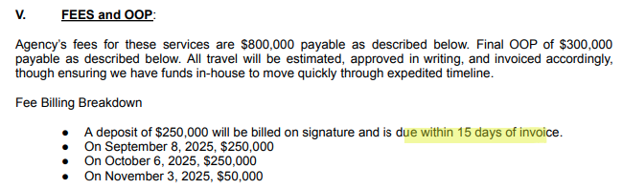

* ***Customers***
  + GL connected, Please search for a customer and select existing customer in dropdown
  + If there are duplicate customers with the same name go to the customers tab in Garage and search the customer. Use the customer ID associated with the Red Antler merchant.

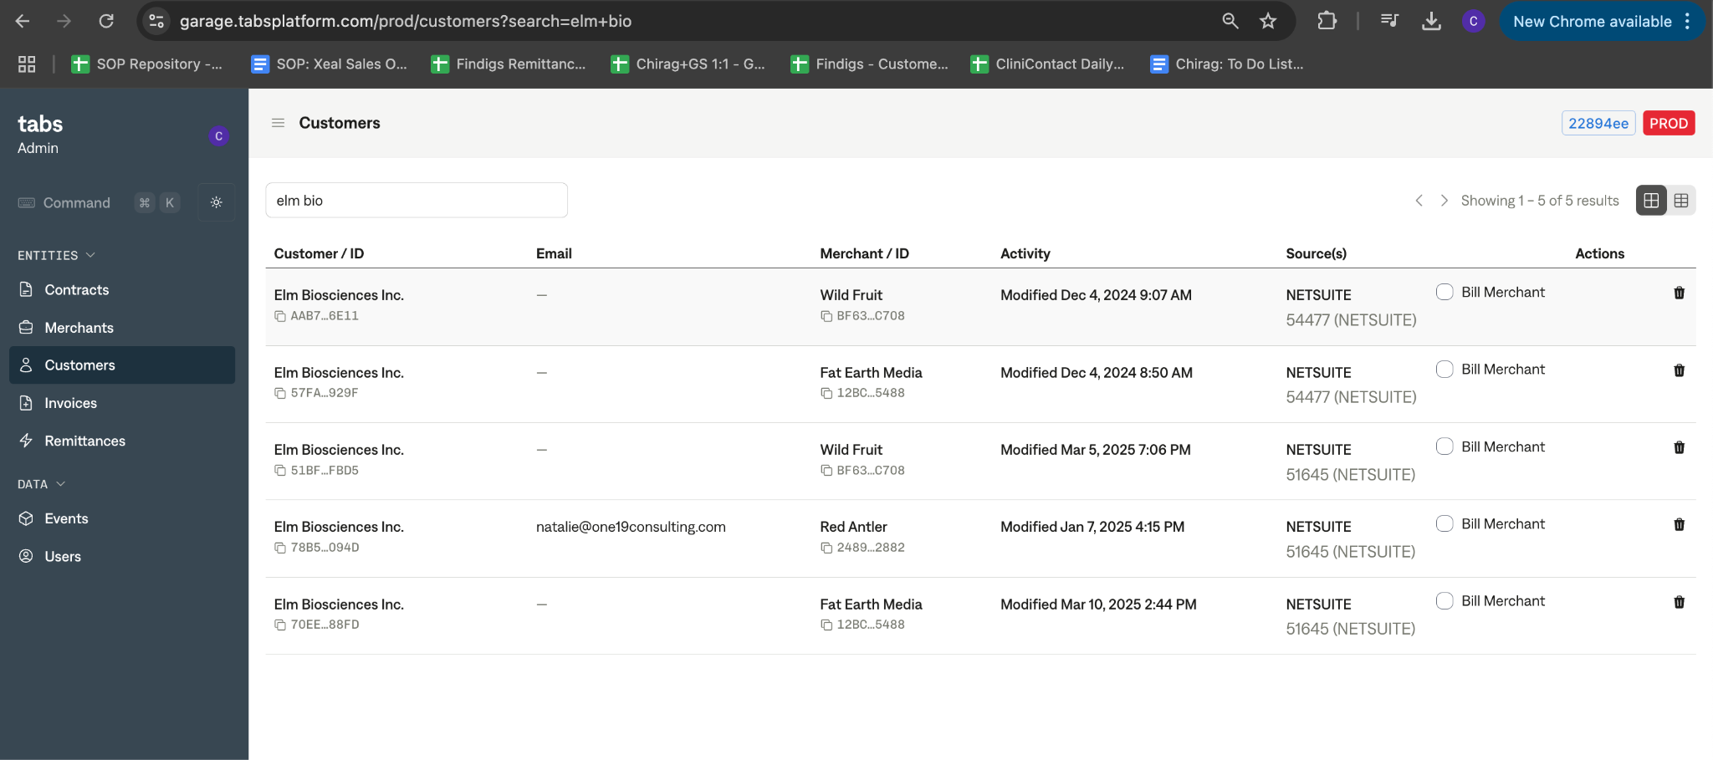

* + If still unsure what customer to select, flag Ops Team [Chirag Manyapu](mailto:chirag@tabsplatform.com)
  + If no customers are found, please create a Tabs customer
    1. Double check the customer is not already created by manually syncing here:
       - Merchants -> red antler -> **Sync Netsuite now**
       - Wait a few minutes before checking again, if customer is still not found than create new customer



* **Item Name**
  + If it’s a project fees, use the project name (if not available in the email body, flag to the US team)
  + If it’s a Out of Pocket Expense (“OOP Fee”s), use “Out of Pocket Expense”
* Under **Item Description,** for project Fees, please specify “Invoice X of Y”
  + X = the sequence of the invoice (e.g. 2)
  + Y = the total number of invoices for the Statement of Work (e.g, 4)
  + In this example if you are creating a billing term for the second invoice, add “Invoice 2 out of 4” under Item Description.
* Integration Items Options, there’s only two. Please follow strictly
  + Client Fees use  **Professional Fees**
  + Out of Pocket use **Pass Through Expense**
  + **Do Not Use: “Client Deposit” -** Anything deposit related is still **“Professional Fees”**
* Dates
  + Use the dates when available on the contract
  + When dates are not available, sometimes it will say “estimate completion in Q4 2024”, then use the first date of the quarter. If it says “estimate completion in a specific month”, then use the first date of the quarter
  + Given these are milestone based project, please process it with a placeholder dates, the stakeholder can change them as they see fit.
* Product Description (FROM EMAIL):
  + Add the "Product Name" Field from the email to the product description in the line item of the invoice. Example below in screen shots.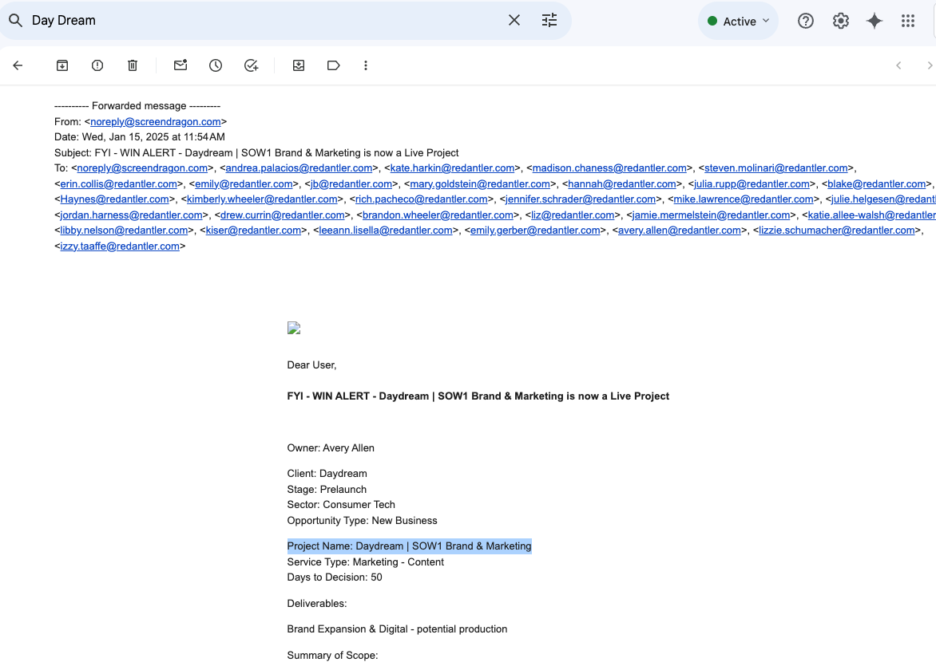
  + Example Contract: a3f5017e-184f-49a8-aaa0-c8aa6f2abde4 (No action required, this is just for illustration)
    1. The "Project Name" field is "Daydream | SOW1 Brand & Marketing"
    2. RA 273 128bcd76-b466-42cc-a8c1-49d315d5a0b4 would then read "Agency Fees - Daydream SOW1 Brand & Marketing" for the line item on the invoice

**Project Creation Workflow**

In order to create a project, we need a few of the following data fields.

1. First navigate to Garage Secrets <https://garage.tabsplatform.com/prod/secrets>
2. Use Super Power “Create Red Antler Project”
3. Get the **Merchant ID**
   1. Obtained via Garage
4. Get the **Customer ID**
   1. Obtain via Garage
5. Determine and populate the **Project Name**
   1. Naming convention “SOW #X: PROJECT NAME”
   2. The Project Name is available on the email where the contract comes from
6. Determine and populate the **Project Type ID**
   1. Options are as follows and use guidance from the contract email
      1. internal = 1
      2. client non billable = 2
      3. client billable-oop = 3
      4. client billable-fee = 4
7. Determine and populate the **Business Type ID**
   1. Options are as follows and use guidance from the contract email
      1. organic = 1 (Typically SOW #2 or greater)
      2. new business = 2 (Typically SOW #1)
8. Determine and populate the **Client Stage ID**
   1. Options are as follows and use guidance from the contract email
      1. pre-launch = 1
      2. early = 2
      3. growth = 3
      4. coop = 4
      5. non-billable = 5
9. Determine and populate the **Budget Fee**
   1. Input the number of the cost of the project, with the dollar sign removed
10. Determine and populate the **Client Director ID**
    1. Obtained via NetSuite
       1. [Red Antler Client Director IDs](https://docs.google.com/spreadsheets/d/1qCIN6wGx1HogoTmyguo3f-WeU17D5a2icS-AMObUrMM/edit?gid=0#gid=0)
    2. Reach out to Royce at the interim. Please start creating an excel spreadsheet to get the Client Director NS internal IDs.
11. Ignore the Project Manager ID
12. You should get the Project ID in return.
13. Use this project ID and mapped it to a specific contract by using the super power.

| Example:  Merchant Id: 24891748-0cee-446e-9c4e-df50c4f72882  {  "customerId": "ec71bc10-de13-4f85-a1e7-aa89a1e1190a",  "projectName": "SOW #5: Pouch Packaging Update",  "projectTypeId": "4",  "businessTypeId": "1",  "clientStageId": "1",  "budgeFee": "2500",  "clientDirectorId": "1330"  } |
| --- |

**Communication Workflow**

* Ops to send slack bot notifications once processed

### —--

### Events Processing (if necessary)

* Any important information on events billing

### Customer Information

* Any important information on specifics customers of this merchant
  + Special memo’s certain invoices require
  + Invoice changes due to merchant/customer relationship

### Feature Requests

* FR 1
  + What is it
  + Why it's important
  + Urgency

### Rewatch Calls

* Rewatch by dates